Database Migration from on-prem to Azure SQL
https://sqlwizard.blog/2020/03/05/database-migration-from-on-prem-to-azure-sql/amp/

Why should you migrate your on-prem database to cloud:
Here are following factors, you would consider when migrating an on-prem database to cloud:
- You want to modernize current IT asset base.
- You want to prepare your database platform for future needs.
- You want to lower your database infrastructure costs.
- You want to increase Business Agility.

Migration Phases:
If you are migrating a mission critical database to cloud, you would need to plan it carefully. Following plan covers most of the different migration phases:
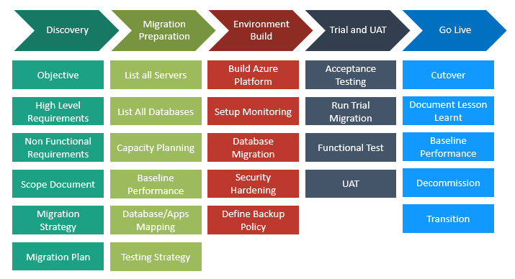

Server/Database Build on Azure:
Every organisation has their own standards, however you can consider following best practices to build your server/database on Azure:
- Provision Azure SQL as per performance baseline.
- Use following link to calculate the DTU required on Azure managed Instance. https://dtucalculator.azurewebsites.net/
- New provisioning option, vCore can be used to map CPU with on-prem servers.
- Restrict SQL Logins and database hardening for better security.
- Setup maintenance jobs as per Microsoft best practices using Azure Automation.
- Improve database performance with optimal configuration.
- Migrate the database swiftly with minimal business impact (within agreed downtime).
- Setup proactive monitoring on servers for efficient Event Management.
- Environment failure testing (Acceptance Testing) : Execute all possible environment failure scenarios to simulate the failure/disaster situations in controlled way and document their fixes and behavior for operational maturity.

Different Database Migration methods:
Here are different database migration methods. You can choose most suitable option as per your database availability and business requirements.
- With Downtime
  - Migration using Data Migration Assistant
  - Migration with Backup and Restore using Azure Blob
  - Migration with Import and Export Data Tier using SSMS
  - Deploy Database from On-prem to Azure SQL Directly through SSMS
- Without Downtime
  - Migration using Azure DMS (Data Migration Service)

Brief summary of each Database migration method:

Migration using Data Migration Assistant:
- Evaluate if database is ready to migrate and produce a readiness report
- Provide recommendations for how to remediate migration blocking issues
- Recommend the minimum Azure SQL Database SKU based on performance counter data of existing database
- Perform the actual migration of schema, data and objects (server roles, logins, etc.)
- Useful for small and less critical databases
- Downtime is required
- SQL Database 2012+ supported.
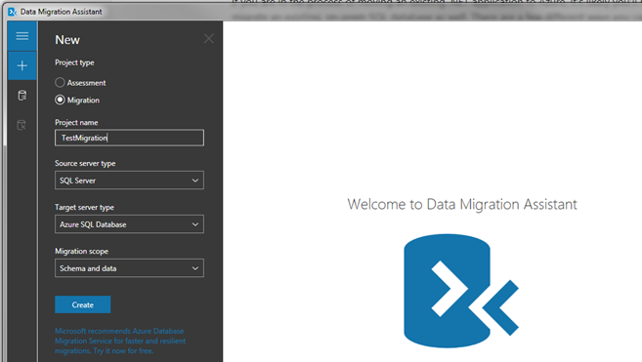

Migration with Backup and Restore using Azure Blob:
- Use Database Migration Assistant tool “Assessment” for following reasons:
  - Detects compatibilities issues
  - Recommends performance and reliability improvements
- Then, use Backup and Restore database using Azure Blob-
  - Ease of Use -Traditional way to migrate the databases using native backups and restores
  - Migration of schema, data and objects
  - Useful for multiple small/big databases
  - Downtime is required
  - Direct migration from SQL Server 2005+ databases
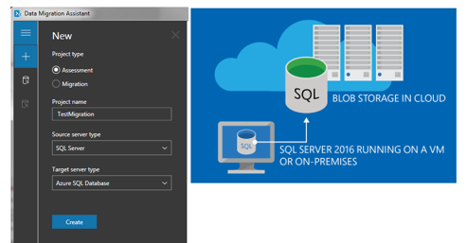

Migration with Export and Import Data Tier using SSMS:
- First, use Database Migration Assistant tool for “Assessment” for following reasons:
  - Detects compatibilities issues
  - Recommends performance and reliability improvements
- Then, use Import and Export Data Tier using SSMS:
  - Migration using bacpac files
  - Migration of schema, data and objects
  - Useful for small databases and less critical databases
  - Downtime is required
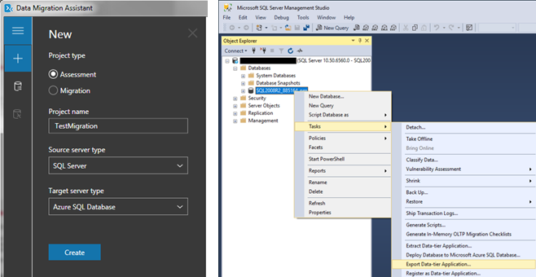

Deploy Database from On-prem to Azure SQL Directly through SSMS:
- First, use Database Migration Assistant tool for “Assessment” for following reasons:
  - Detects compatibility issues
  - Recommends performance and reliability improvements
- Then, use Deploy Database from On-prem to Azure SQL Directly through SSMS:
  - Direct migration from On premise server to Azure SQL
  - Migration of schema, data and objects
  - Useful for small databases and less critical databases
  - Downtime is required
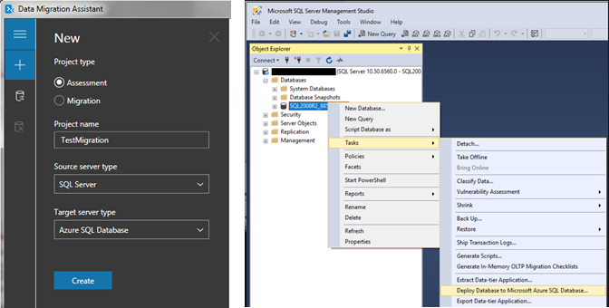

Migration using Azure DMS (Data Migration Service):
- Fully Managed Service for Seamless Migrations
- Leverages Data Migration Assessment tool for following assessment
  - Detects compatibility issues
  - Recommends performance and reliability improvements
- Fire and Forget Migration
- Migration of schema, data and objects
- Useful for big databases and business critical databases
- No or less downtime is required
- Multiple Database engine supported
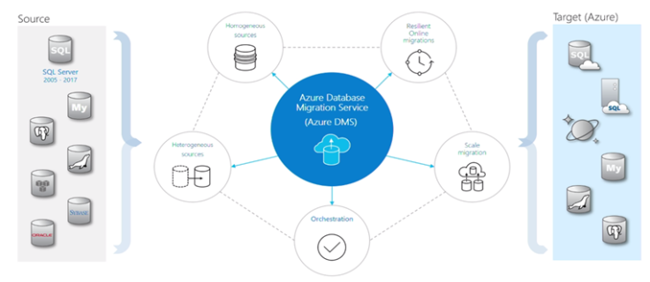

Benefits of Database Migration on Azure:
Here are the following benefits of migrating an on-prem database to Cloud:
- Flexibility and scalability.
- Improved supportability.
- Increased up-time.
- Enabler for improved RPO (Recovery point objective) & RTO (Recovery time objective).
- Excellent Performance in latest version of SQL Server.
- Better Security.
- Improved Index Management.

Potential challenges of Database Migration on Azure:
While your specific environment will determine the challenges that apply to you, there are some general drawbacks associated with database migrations on cloud that you will want to consider.
- Compliance requirements migrating your sensitive data on cloud.
- Latency when using database on clouds.
- If your hardware is controlled by someone else, you might lose some transparency and control when debugging performance issues.
- Shared resources which might impact database performance.
- Uncontrolled downtime.

